Search Activity – Finding an application where the inventor has a common name

This search activity is much harder than it first appears. You need to be wary when searching for names, particularly inventor names. Different Patent Offices store names in different ways. If you are unfamiliar with a database and how names are stored, it is a good idea to find out from the ‘help’ source.
Find the application that has the inventor name Andrew Michael SCOTT in the New Zealand patent database available at
https://www.iponz.govt.nz/
http://app.iponz.govt.nz/app/Extra/IP/PT/Qbe.aspx?sid=636122801360403986.
Hint 1. The co-inventor is David William Bell WESTERMAN.
Hint 2. Use a wildcard (*)
Step | Description of step | Model answer
1 | Access the patent search database | Access the link
2 | Find the field in which to enter your query. | Click on Client/Interest Search and use the Inventor Name field.
3 | Decide on your search query | Enter the full inventor name in inverted commas ie “Andrew Michael Scott” then press Search
4 | Do you have the correct result? If not, why not? | No, there are no results. Perhaps the database records only the family name and perhaps the first name.
5 | Try again using only the family name and the first name. | Enter “Andrew Scott” and resubmit.
6 | Do you have the correct result? If not, why not? Note the presentation and the punctuation of the inventor names. | There are 7 results  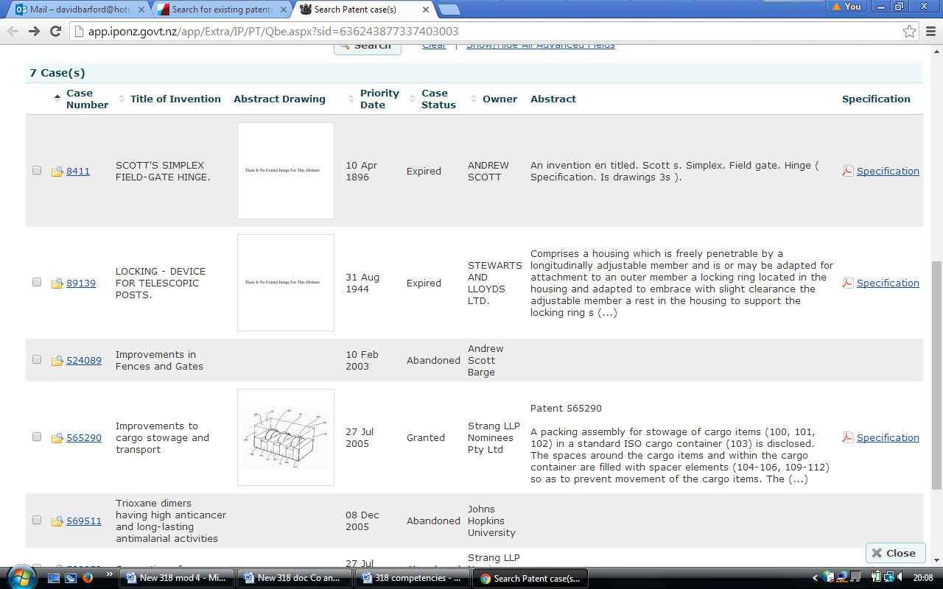 The first have the inventor as Andrew Scott; the others have the names Andrew and Scott but not as required. Also it looks as though the format is surname first, then a comma, then the other name(s) so possibly the first two hits are by Scott Andrew.
7 | Having regard to the way the names are shown, repeat the search. | Enter “Scott, Andrew Michael “and resubmit.
8 | Did this give the right result? | Yes, the patent number we are looking for is 216540
9 | Can you think of another way to find the right result, using wildcards? | Use * which represents zero, one or many characters, ie Scott* AND Michael* AND Andrew*
10 | Did the wildcards give the right result? | Yes, the first result was the one we were looking for.

